**Group 07’s Design Specification**

**Group Members:**

1. Nguyễn Anh Kha – 1611490
2. Phạm Tuấn Khoa – 1611634
3. Vũ Đăng Khoa – 1611645
4. Dương Văn Vũ Linh – 1511734

**Project Name: Simple calculator with 16x2 LCD**

* *System Description*:
  + Basic scientific calculator which takes user input via 5x5 matrix keypad, calculates the result using a microcontroller and displays ouput to 16x2 LCD.
* *Basic flow:*

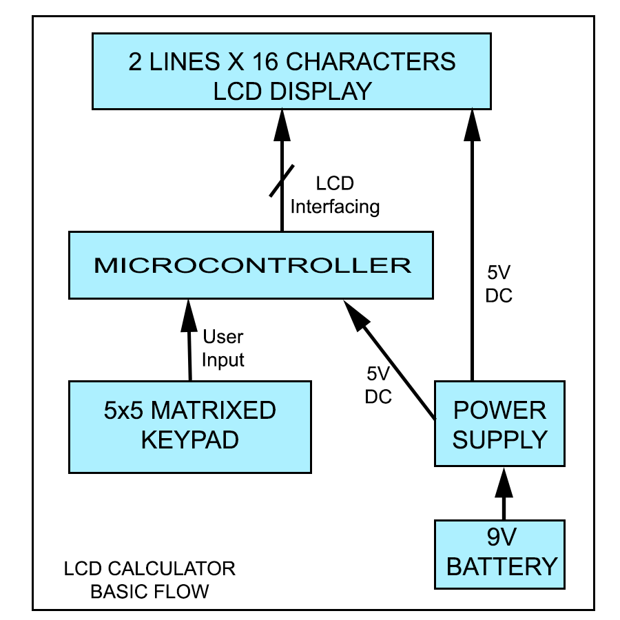

* *System architecture:*

1. 5x5 (or 4x4) matrix keypad for user input.
2. Main CPU capable of handling single-precision floating point format of IEEE 754. [1]
   * Atmega328
   * PIC16f877a
   * STM32F030F4F6
3. Green or blue 16x2 LCD.
4. Non-rechargable 9V battery for power supply.

* *Working Environment:*
* Indoor settings portable device. [2]
* Room temprature (15-35 degrees Celcius)
* *System connectivities:*
* Internal 9V battery
* *System block diagram:*

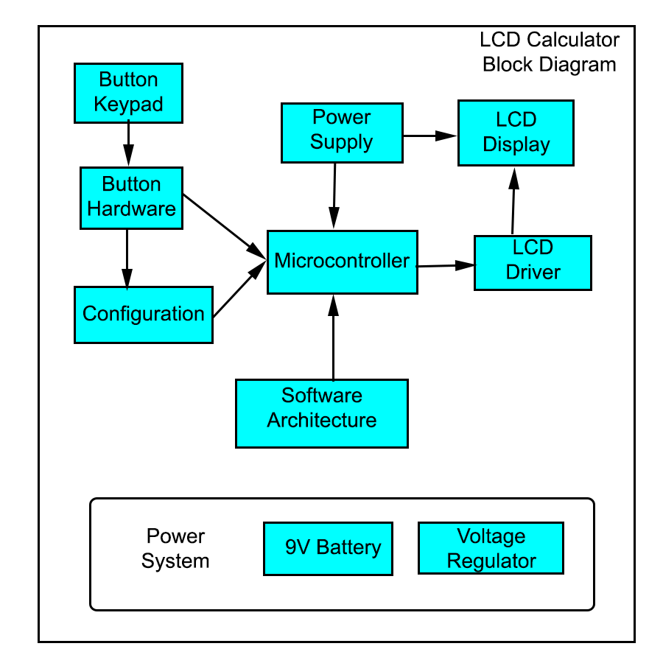

* *System limitations:*

1. Arithmetic statement must be syntactically correct and mathematically legimate. (Only zero division and integer overflow errors are handled)
2. Input length of arithmetic statement is fewer than 16 characters due to the limitations of 1602 LCD.

*-* **Button Interface***:*

Equip user with a 4x4 matrixed keypad for arithmetic setence input.

*Requirements:*

* Internal software button debounce.
* Long lived and stable buttons.

Number of part: 01

Estimated cost: 50,000 VND

- **Microcontroller: [Choose one]**

Internal microcontorller for processing scientific calculations.

* Atmega328: 65,000 VND x01
* PIC16f877a: 65,000 VND x01
* STM32F030F4F6: 50,000 VND x01

*Requirements:*

* Cheap, low power consumption.
* Sufficient powerful for calculating.
* LCD 16x2

**- 9V Battery:**

Provide a graphical user interface for input and output of calculations.

*Requirement*: None

Number of part: 01

Estimated cost: 40,000 VND

**- Power system:**

Supply the system with sufficient power.

9V Battery [Non-rechargable]: 10,000 VND x01

Voltage regulator: use built-in voltage regulator of microcontroller and/or PWM using software architectures.

**- Battery case:** 15,000 VND x01

Acts as a holding case for battery.

*Requirement*: small size.

**- Custom PVC case:**

Provide protection for the system against physical and/or electronic damage. Also for cosmetic purposes.

Estimated cost: 50,000 VND

**- Other cost incurred estimate: 50,000 VND**

**Total cost estimate: 275,000 VND**

**Software architecture:**

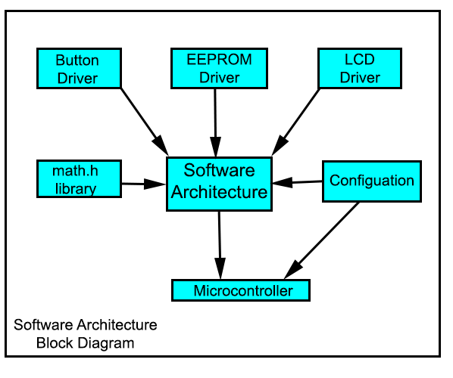

1. **Button Driver:**

Provide communication between buttons and microcontroller

Estimated CPU consumption: 100 Bytes

1. **EEPROM Driver: [3]**

(built-in controller by manufacturer)

Provide communication with EEPROM.

Estimated CPU consumpiton: Not available

1. **LCD Driver:**

Provide communication between microcontroller and LCD display.

Estimated CP consumption: 200 bytes

1. **Math.h library: [4]**

Math.h header defines various mathematical functions and one macro. Extremely useful for simple scientific calculations.

Useful functions for the project:

- double acos(double x): returns the arc cosine of x in radians.

- double asin(double x): returns the arc sine of x in radians.

- double atan(double x): returns the inverse tangent of x in radians.

- double cos(double x): returns the cosine of a radian angle x.

- double sin(double x): returns the sine of a radian angle x.

- double tan(double x): returns the tangent of a radian angle x.

- double log(double x): returns natural logarithm (base-e logarithm) of x.

- double log10(double x): returns the common logarithm (base-10 logarithm of x).

- double pow(double x, double y): returns x raised to the power of y.

- double sqrt(double x): returns the sare root of x.

*Reference links:*

[1] – [IEEE Standard for Floating-Point Arithmetic (IEEE 754)](https://en.wikipedia.org/wiki/IEEE_754)

[2] – [Indoor temprature (room temprature)](https://en.wikipedia.org/wiki/Room_temperature)

[3] – Datasheets:

* [Atmega328](http://ww1.microchip.com/downloads/en/DeviceDoc/Atmel-42735-8-bit-AVR-Microcontroller-ATmega328-328P_Datasheet.pdf)
* [PIC16f877a](http://ww1.microchip.com/downloads/en/DeviceDoc/39582b.pdf)
* [STM32F030F4P6](https://www.st.com/resource/en/datasheet/dm00088500.pdf)

[4] – [Math.h header](https://en.wikibooks.org/wiki/C_Programming/math.h)